CASE STUDY
cOMMERCIAL AGENCY

strategic acquisition advice  PROJECT SUMMARY  Strategic acquisition advice to a retained client | TEAM  Manchester Commercial Agency | LOCATION  1606 Bridgwater Gateway, Taunton Way
 | CLIENT  NuStyle Products Limited | DATES  February 2023
Subheader  Graham + Sibbald (G+S) provided strategic acquisition advice to retained clients NuStyle Products Limited on their growth strategy across the UK.  We acquired Unit 1606 Bridgwater Gateway, Taunton Way, Bridgewater a brand new built to suit industrial unit on a leasehold basis. The acquisition was the third acquisition for NuStyle within England giving NuStyle a distribution centre within the Southwest of England following on from the acquisitions in the Northeast of England and West Midlands. | 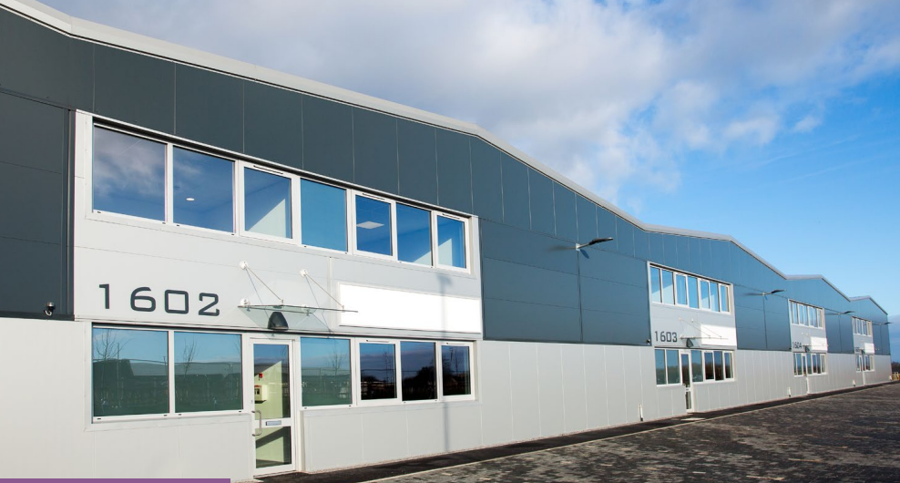

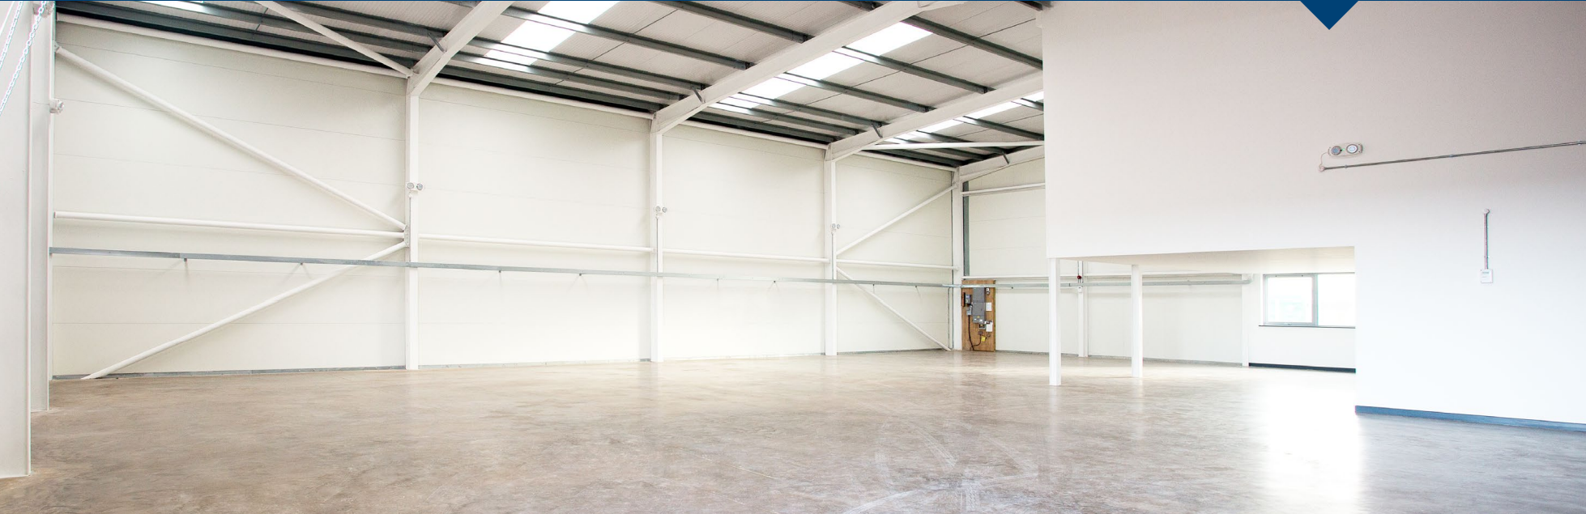
WHY g+S
Our experienced Agency team provides a comprehensive range of services covering all aspects of the disposal of commercial property. We work in all key sectors, including office, retail and industrial property, hotels and leisure and student accommodation.
If you are looking to dispose of commercial property, G+S are well placed to assist with both standard and complex sales, aiming to maximise our clients return.
APPROACH
Graham + Sibbald discussed the requirement with the client to understand their brief. Upon securing the brief, we undertook a search of the market to find the industrial property and shortlisted Unit 1606 Bridgewater Gateway as a potential alongside eight other options.
Once shortlisted we undertook an initial viewing alongside the client. We then looked at evidence of similar industrial units and comparable evidence and provided a report back to our client with our thoughts on rents, location, term, and our thoughts on what terms could be achievable. We then opened negotiations with the landlords agent and within four working days had an agreed Heads of Terms and over to solicitors to agree the lease. The Lease was agreed within 3 months and access was granted on practical completion of the property.
Graham + Sibbald throughout the process kept our client up to date on all progress and liaised with the selling agent and the solicitors to make sure the process was moving at all times, allowing our client to have a smooth transaction.
This helps to streamline the process and remove unnecessary delays which frustrate clients. Good options, with the best possible terms make a client’s decision making much easier.
KEY CHALLENGES
The location of the property provides great access up and down the M5 Motorway providing great transportation links for their distribution centre. The area also provides potential for growth for the business over the next five to ten years.
With the above taken into account and the interest from other competing parties, the key challenge was to get the offer correct and also show to the landlord the strength of our clients covenant against other interested parties. We managed to show our clients covenant strength through track records, accounts and D&B report/rating.
As this unit was brand new and was built to suit with occupation on practical completion, we had to make sure our client was covered and that the unit was provided to the specification noted. We provided our client with full specification checks and agreed snagging repairs to the property covered by the developer and landlord for up to 12 months.
RESULTS
We were successful in our approach to acquiring the property on a leasehold basis with other interested parties showing interest. We provided a comprehensive service to our client from start to finish. We managed the process on our client’s behalf until completion liaising with solicitors and the agent acting for the landlord. We managed to have all matters concluded within 12 weeks allowing for our client to have no delays of entry on practical completion of the unit.
Our client now benefits from a well located distribution centre which ticks all the boxes and also allows for future growth as the business keeps growing.
KEY MESSAGE
G+S have the coverage on a national level and knowledge at local level to deliver exactly what the client requires. We also have mutually beneficial relationships with similar organisations to NuStyle Products Limited. We have an understanding of the requirements of these organisations and knowledge of what input they require.
Delivering quality advice to clients, ensuring they can rest in the knowledge that when they require acquisition or disposal Agency input, they know it will be managed quickly and appropriately.
Key contacts:
Bilal Ashraf
Associate
Bilal.ashraf@g-s.co.uk
07341 547 047

